**Attachment: Storm Door Standards**

Indicate on your request form the manufacturer, style and model of the storm door you choose to install. Your selection must comply with the standards set in the storm door policy.

Please note the color of the installed door must match the color of the entrance door and trim.

Below are the currently approved storm door models:

  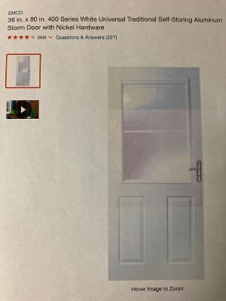

*Traditional Jalousie Traditional Self-Storing Aluminium,EMCO Must Be Painted Rainbow Red To Match Entrance Door.*